ReactJS Hands-On Lab
Cohort Tracker – Styling with CSS Modules

Objective
In this lab I was given a starter React project called cohorttracker that displays a list of training cohorts using a CohortDetails component. My task was to restore the project's dependencies and then style the component using a CSS Module, so that each cohort is shown inside a bordered, rounded box, and the status heading changes colour depending on whether the cohort is ongoing or not.

Step 1: Restoring the packages
I unzipped the provided cohorttracker project into my lab folder, opened a command prompt inside it, and ran npm install to restore all the node packages:
npm install
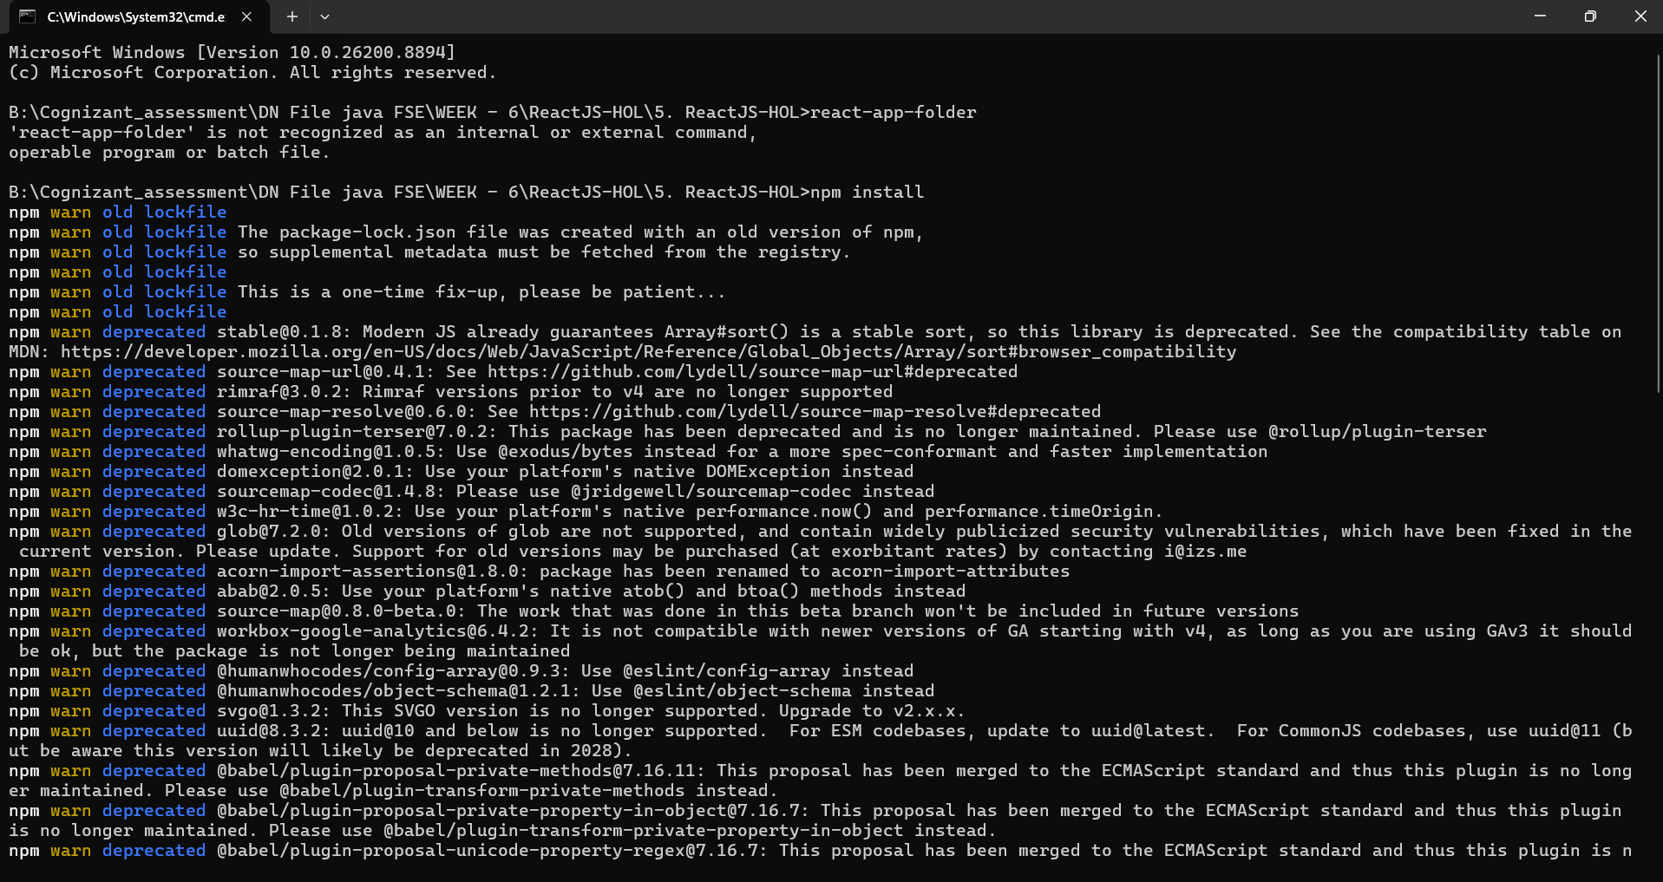
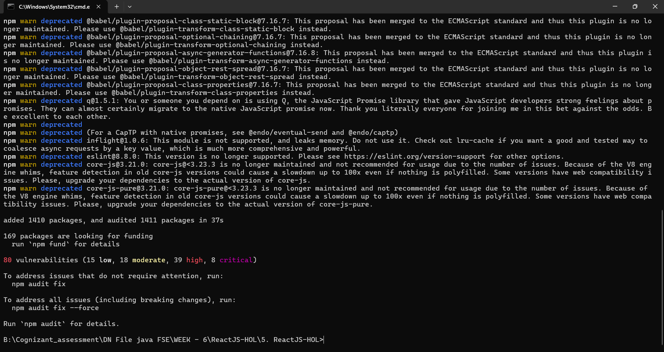
npm showed a few deprecation warnings, which is expected for an older lockfile, but the install finished successfully with all the packages added.

Step 2: Creating the CSS Module
Inside the src folder, I created a new file named CohortDetails.module.css. In it, I defined a box class to give each cohort card a border, rounded corners and spacing, and a tag selector for dt elements to make the field labels bold:
.box {
width: 300px;
display: inline-block;
margin: 10px;
padding: 10px 20px;
border: 1px solid black;
border-radius: 10px;
}
dt {
font-weight: 500;
}

Step 3: Updating CohortDetails.js
I imported the CSS Module into CohortDetails.js and applied the box class to the outer div. I also updated the h3 heading so that its text colour changes based on the cohort's currentStatus — green when it is "Ongoing" and blue otherwise:
import styles from './CohortDetails.module.css';
function CohortDetails(props) {
return (
<div className={styles.box}>
<h3 style={{ color: props.cohort.currentStatus === "Ongoing" ? "green" : "blue" }}>
{props.cohort.cohortCode} -
<span>{props.cohort.technology}</span>
</h3>
<dl>
<dt>Started On</dt>
<dd>{props.cohort.startDate}</dd>
<dt>Current Status</dt>
<dd>{props.cohort.currentStatus}</dd>
<dt>Coach</dt>
<dd>{props.cohort.coachName}</dd>
<dt>Trainer</dt>
<dd>{props.cohort.trainerName}</dd>
</dl>
</div>
);
}
export default CohortDetails;
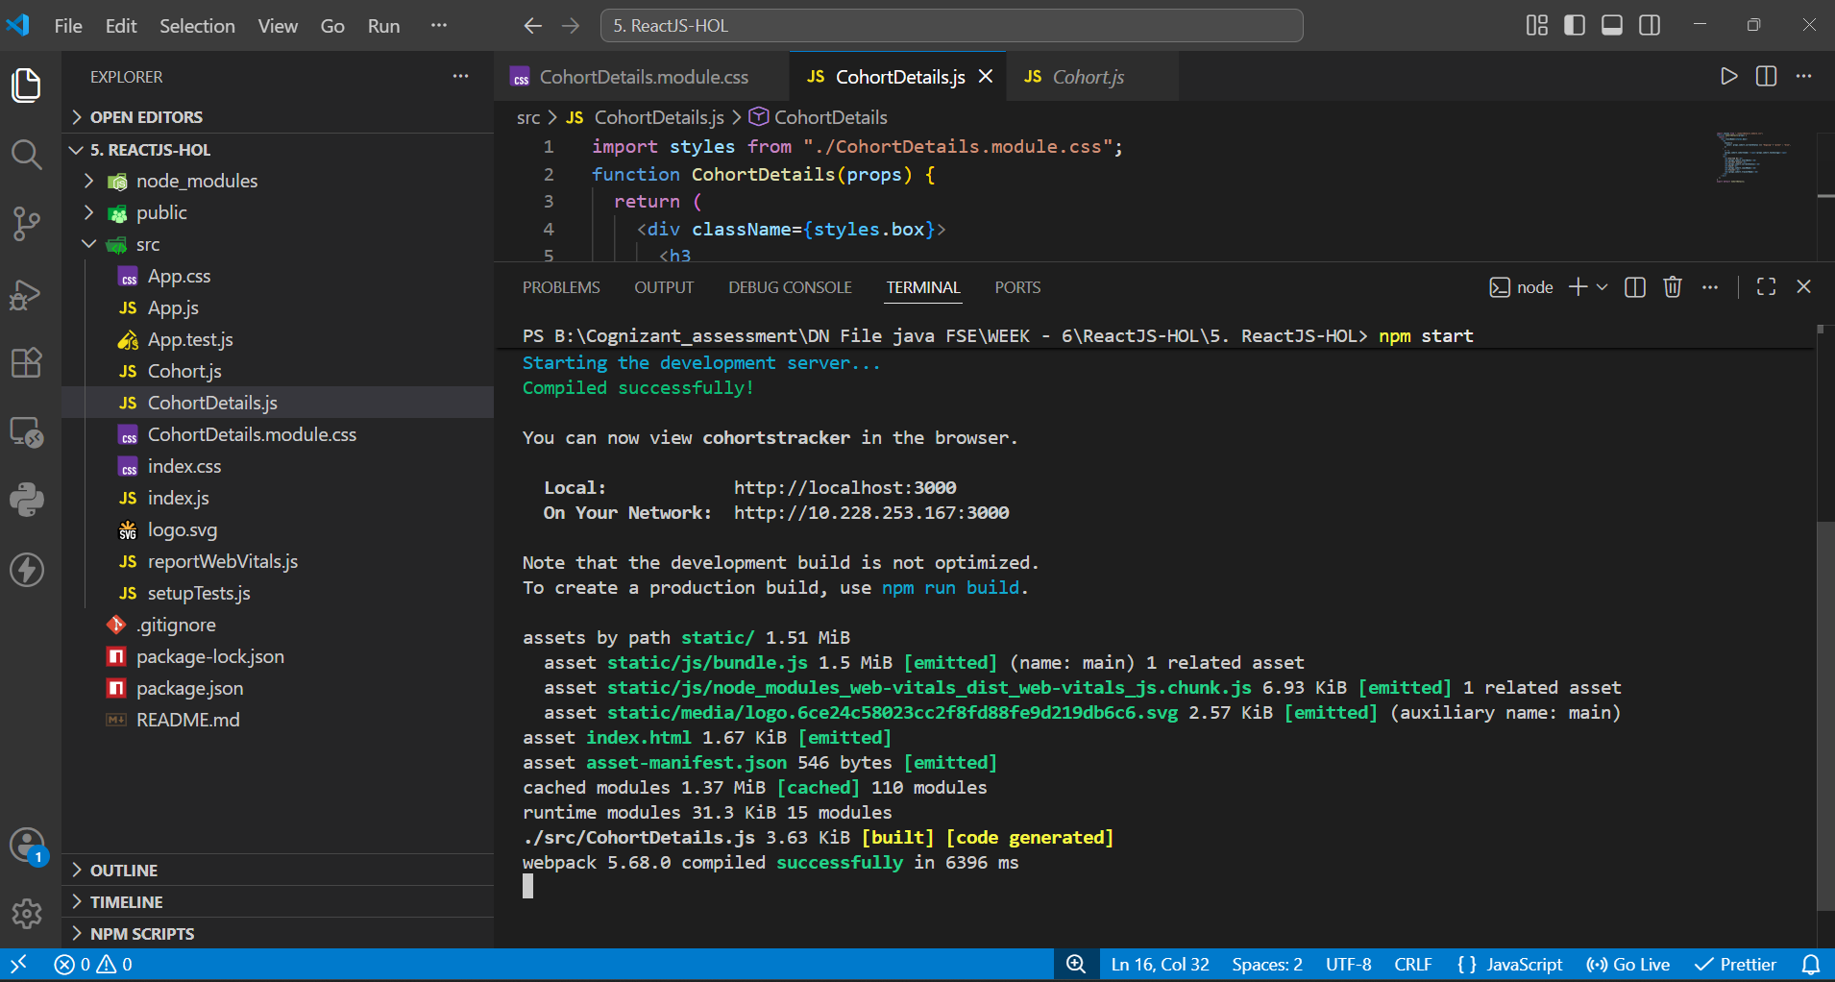
The screenshot above shows the final CohortDetails.js file in VS Code, along with the terminal output after running npm start — webpack compiled successfully with no errors.

Step 4: Running the app
I ran npm start from inside the project folder, which launched the development server and opened the app at localhost:3000 in the browser:
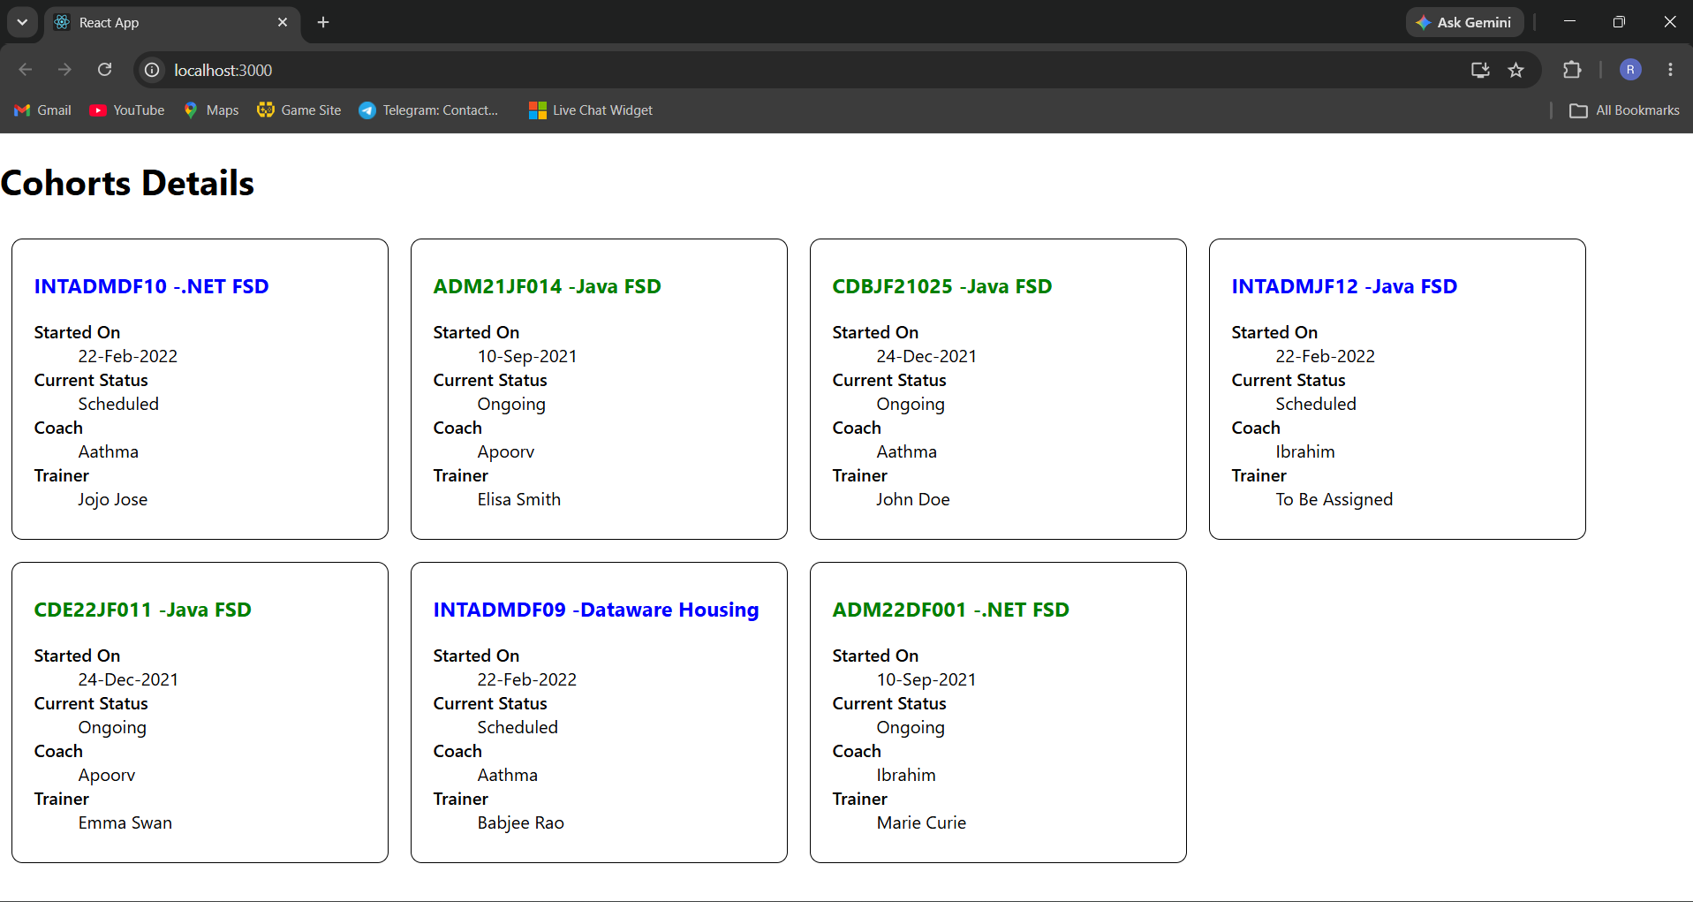
The page shows all seven cohorts, each inside its own bordered, rounded box. Cohorts with a currentStatus of "Ongoing" have their heading in green, while the "Scheduled" ones are shown in blue, confirming that both the CSS Module styling and the conditional colour logic are working as expected.

Conclusion
This lab helped me understand how to use CSS Modules to scope styles to a single component, how to apply a module class using className, and how to set inline styles conditionally based on a prop value. The final output correctly displays every cohort with the right styling and status-based colour coding.

